## **Step 1: Create a GitHub account**

The easiest way to get started is to create an account on [GitHub.com](https://github.com/" \t "https://opensource.com/article/18/1/_blank) .

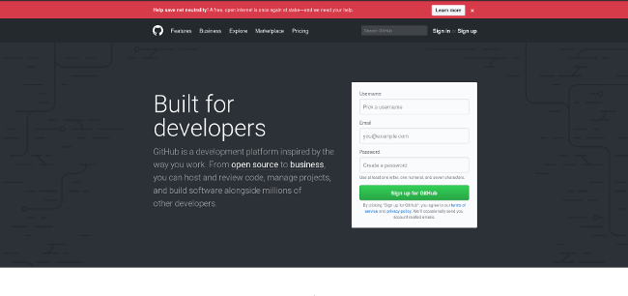

Pick a username (e.g., octocat123), enter your email address and a password, and click ****Sign up for GitHub****. Once you are in, it will look something like this:

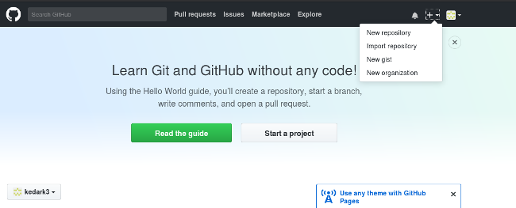

## **Step 2: Create a new repository**

A repository is like a place or a container where something is stored; in this case we're creating a Git repository to store code. To create a new repository, select ****New Repository**** from the + sign dropdown menu (you can see I've selected it in the upper-right corner in the image above).

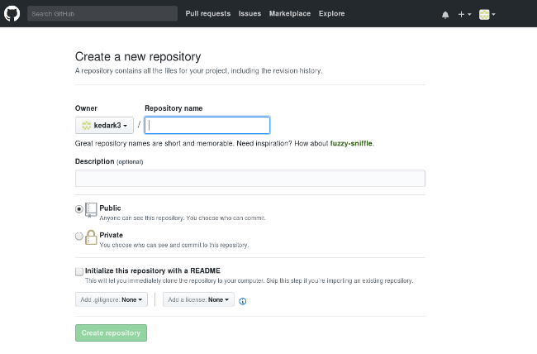

Enter a name for your repository (e.g, "Demo") and click ****Create Repository****.